Bald Eagles Research for “My Eagle Book” 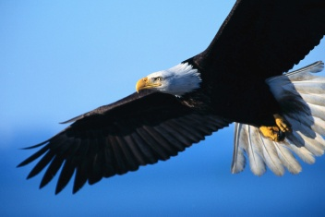
Name _________________________________
Use your Xplor magazine and eagle library books to gather information. Record your discoveries about important facts on the bald eagle.
Physical Appearance - characteristics of a Bald Eagle (what do they look like) –

Location - Bald Eagles only live in what part of the world?

Food - What do bald eagles eat?

Habitat – what kind of areas do bald eagles like to live -

Family – what kind of families do bald eagles have? Where do they build their nests? What do their nests look like? How do eagles reproduce? What are baby eagles called?

Endangered Species – Why were eagles considered an endangered species from 1940-1990s? What did scientist discover? Are bald eagles still on the “endangered species” list?

Eagles in Missouri – eagles in St. Charles County – Are there any bald eagles nearby?

Use your research to make an accordion book about bald eagles. Your PRR teacher will show you how next week!

