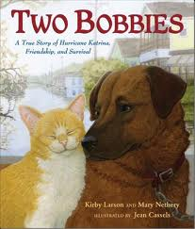
Service Learning – Pets Working Together and Pet Protection
Here is a true story about two brave friends and how through teamwork they managed to survive. Don’t worry…there is a happy ending to this story thanks to some special humans! Listen to the story and talk about the ideas below:
- What kind of disaster did the two main characters encounter?
- After the storm was over, what did the “Two Bobbie’s” world look like?
- Which “Bobbie” do you think was the main leader of the two Bobbies and why?
- How did the Two Bobbies communicate to the humans they were a “team”?
- Near the end of the story it became clear the Two Bobbies were a “team” even before the big storm. Explain how.
- What did humans do to help this amazing animal team?
- Why was the final scene of the story the best possible outcome for the two Bobbies?

